LabVIEW source only VI errors for SaveVersion Feature

Revised: 8/8/2024 10:00 AM
TestStand Version: 2024 Q3
Author: Vishal S
Feature Spec:
Dependencies: Perforce

Description
LabVIEW introduced a new option ‘Maintain the save version of loaded projects by default’ in LV 2024 Q3 onwards, which is enabled by default. When this is enabled, even when we save or mass compile files with a higher LabVIEW version, the version of the VI would not change to current LabVIEW version, but instead be same as the project/library/class’s version. Thus, when user tries to run steps containing these VIs, they see an error as LabVIEW VI version doesn’t match the RTE version (which was not the case earlier).
Thus, we updated the error strings to refer to the new help topic ‘Executing source-only VIs in LabVIEW Runtime Engine’ which contains the fix, when they encounter this issue.

Preparation
- Install TestStand 2024 Q3 or later
- Install LabVIEW 2024 Q3 or later.
- Use Media mentioned in this test plan from //TestStand/WebPages/TestCases/Adapters/LabVIEW/Media/SaveVersion Media.
- Mass compile the folder ‘SaveVersion Media’ using LabVIEW – Tools->Advanced->Mas Compile

Note:
- The test media is saved in LabVIEW 2021, if you are modifying the files, it should be saved in the least supported LabVIEW version

Validation

LV RTE version is set to LV version under test:
- Launch TestStand
- Ensure “Build Source Files and Execute Files” and “Version Independent Runtime Engine” is unchecked. Restart if required.
- Set the LV Adapter to use LV RTE and set version to LabVIEW version under test (for example 25.1).
- Open VerifyErrorsAndExecute.seq
- Verify you see the below error for the steps “Loose VI” and “VI in Library”
- 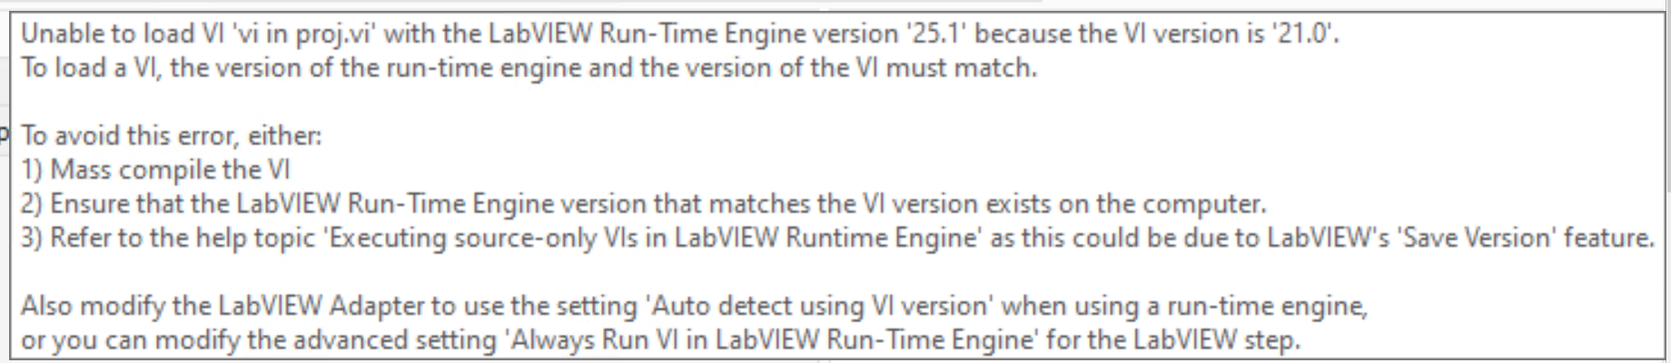
- Verify you see the below error for the step “Class Member Call VI”
- Verify you see the below error for the step "VI in Project”
- Open VerifyErrors.seq
- Click on both steps and ensure error looks like below
- 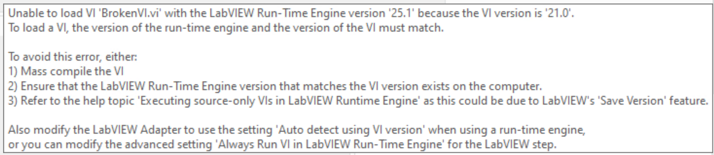
- Check “Version Independent Runtime Engine” and set RTE Version to AutoDetect
- Click on step ‘Broken VI - dependent VI in lower LV’
- 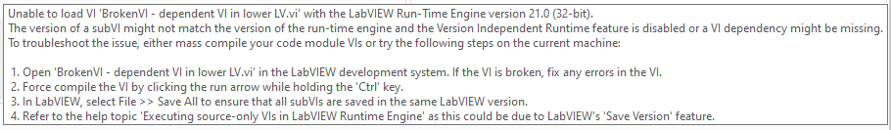
- Restart TestStand and click on same step again
- Ensure error message looks like below
- Open VerifyErrorsAndExecute.seq and click on step ‘LooseVI’.
- Ensure error message looks like below
- Set RTE version to LabVIEW version under test.
- Shutdown TestStand.

Solution 1:
- Mass compile the files with default LabVIEW settings (‘Maintain save version of project’ option is unchecked)
- Enable “Version Independent Runtime Engine” option
- Set LV RTE version to the version of LabVIEW used to mass compile.
- Restart TestStand
- Open VerifyErrorsAndExecute.seq and ensure there are no more errors for all the steps
- Execute the sequence file and ensure there all tests are passed

Solution 2:
- Ensure TestStand is shutdown and open LabVIEW
- Go to Tools->Options->Environment.
- Uncheck ‘Maintain save version of project’ option
- Clear compiled cache – Tools->Advanced->Clear Compiled Object Cache
- Set the save version of LabVIEW project (project.lvproj) to 'Editor version' in the project's properties.
- Delete the .lvversion file from “VI with .lvversion file” folder
- Mass compile the folder ‘SaveVersion Media’ again
- Open TestStand
- Set adapter to use LabVIEW Dev
- Recreate the step ‘PropertyNode VI’ using current LabVIEW version, by keeping all data same and delete the old step
- Set adapter to use LabVIEW RTE and select AutoDetect / LV version used to mass compile
- Open VerifyErrorsAndExecute.seq and ensure there are no more errors for all the steps
- Execute the sequence file and ensure there all tests are passed

